|  |
| --- |
|  |
| Capstone Project Document |

FLY AWAY PLUS

Report #3 – User Requirement Specification

|  |  |  |
| --- | --- | --- |
| **Fly Away Plus** | | |
| **Group Members** | Hoàng Nghĩa Đức | SE02882 |
| Dương Thanh Hải | SE02856 |
| Nguyễn Minh Hoàng | SE02819 |
| Trần Mạnh Hiếu | SE02778 |
| Phan Tiến Lực | SE02923 |
| Lê Minh Thúy | SE02881 |
| **Supervisor** | Mr. Nguyễn Văn Sang | |
| **Project code** | FAP | |

**- Hanoi, 05/2015 –**

Table of Contents

**1.** **USER REQUIREMENTS SPECIFICATION** 2

**1.1.** **Introduction** 2

**1.1.1.** **Purpose** 2

**1.1.2.** **Definition and Acronyms** 2

**1.2.** **Overall Description** 2

**1.2.1.** **Business Process Overview** 2

**1.2.2.** **Product Features** 9

1.1.2. User characteristic 10

**1.3.** **Functional Requirements** 11

**1.3.1.** **Common Module** 11

**1.3.2.** **Suggest Module** 11

**1.3.3.** **Social Module** 11

**1.3.4.** **Room Module** 11

**1.3.5.** **Account Module** 11

**1.3.6.** **Management Member’s account** 11

**1.3.7.** **Management Report** 12

**1.4.** **Non-functional Requirement** 12

# **USER REQUIREMENTS SPECIFICATION**

## **Introduction**

### **Purpose**

This document will provide the describing of general requirement and non-functional requirements of our FAP system. It also describes the requirement scope of each phase in the project.

### **Definition and Acronyms**

|  |  |
| --- | --- |
| Terms | Description |
| FAP | Fly Away Plus |

## **Overall Description**

### **Business Process Overview**

FAP is a social network. Therefore, that system will implement the following processes:

#### Register workflow

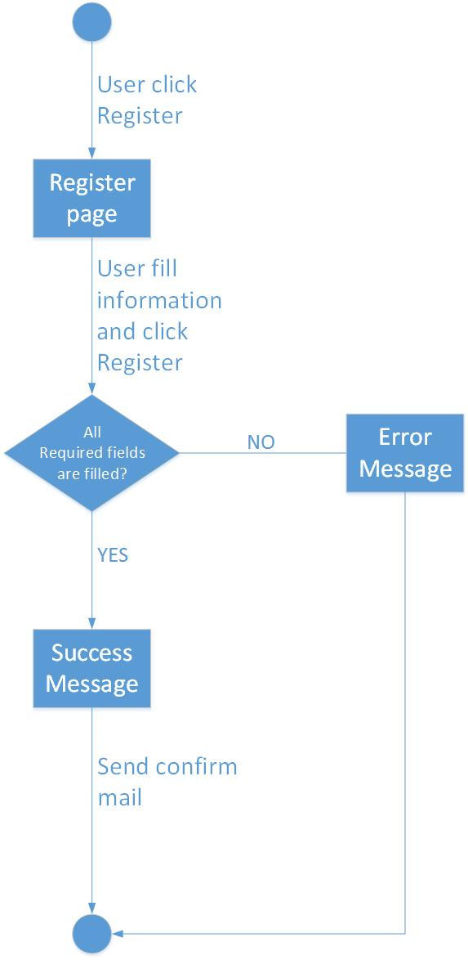

**Brief description**: Guest can use this function.

**Steps**:

Step 1: User click Register.

Step 2: System return register page.

Step 3: User fill all required fields and click Register or press Enter.

Step 4: System return complete message.

Step 5: System send confirm mail to user’s entered email.

#### Search workflow

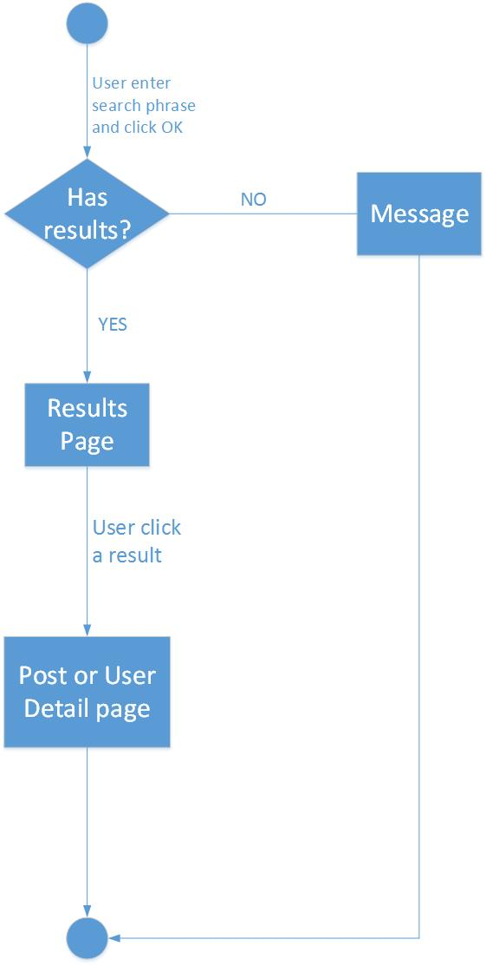

**Brief description**: Guest and Member can use this function.

**Steps**:

Step 1: User input keyword into search text box and click Search or press Enter

Step 2: System return search results or message if nothing found.

Step 3: User can click returned results to view.

#### Look around workflow

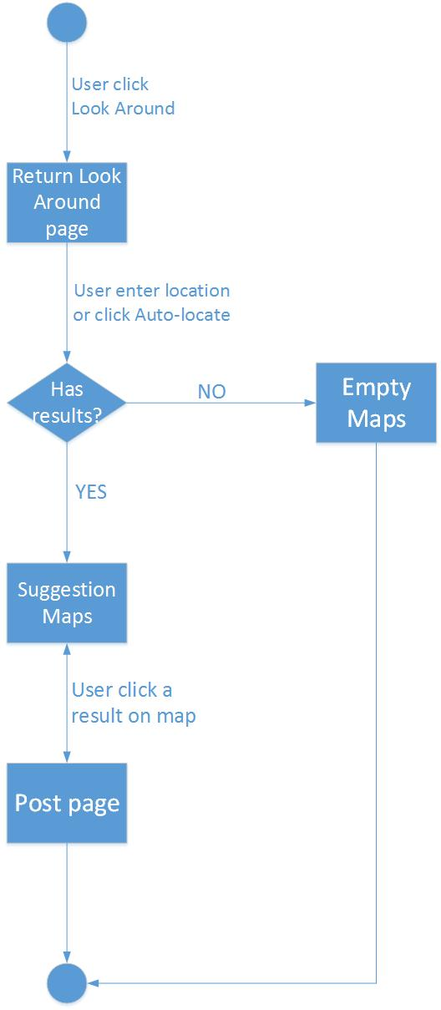

**Brief description**: User can use this function.

**Steps**:

Step 1: User click Look around.

Step 2: System return Look around page.

Step 3: User enter location and click Find or choose auto detect location.

Step 4: System return suggestions depend on user’s location.

Step 5: User click results to view.

#### Like/Dislike/Share/Report workflow

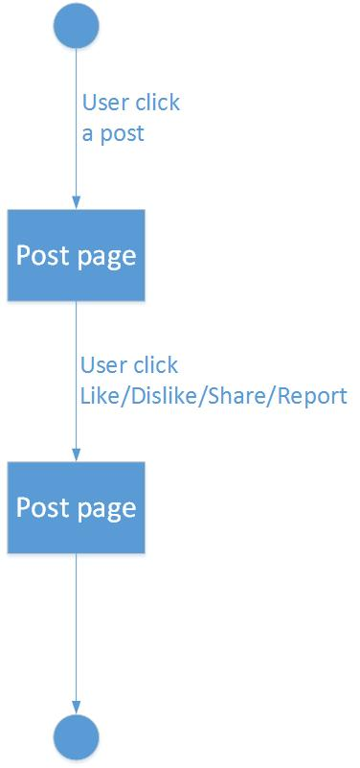

**Brief description**: User can use this function.

**Steps**:

Step 1: User click a Post in Homepage or search result or suggestion.

Step 2: System redirects user to chosen post.

Step 3: User click Like/Dislike/Share/Report.

#### Room workflow

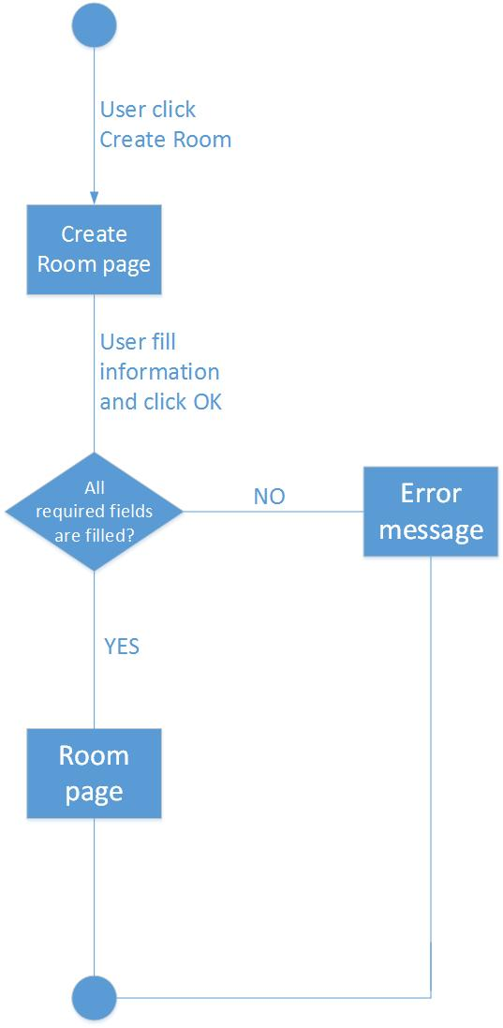

**Brief description**: User can use this function.

**Steps**:

Step 1: User click Create Room.

Step 2: System return Create Room page.

Step 3: User fill all required fields and click Create or press Enter.

Step 4: System redirect user to created room or display error message.

#### Comment/Tag workflow

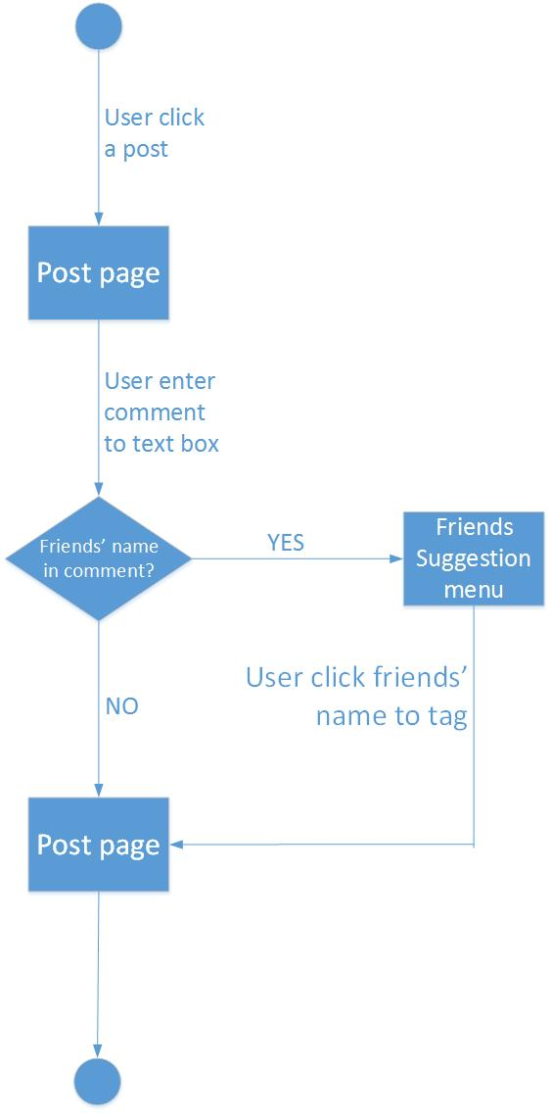

**Brief description**: User can use this function.

**Steps**:

Step 1: User click a Post in Homepage or search result or suggestion.

Step 2: System redirects user to chosen post.

Step 3: User types comment to text box.

Step 4: System suggests user’s friends if user types friends’ name.

Step 5: User chose friends’ name to tag or press Enter to comment.

#### Add/Remove/Follow users workflow

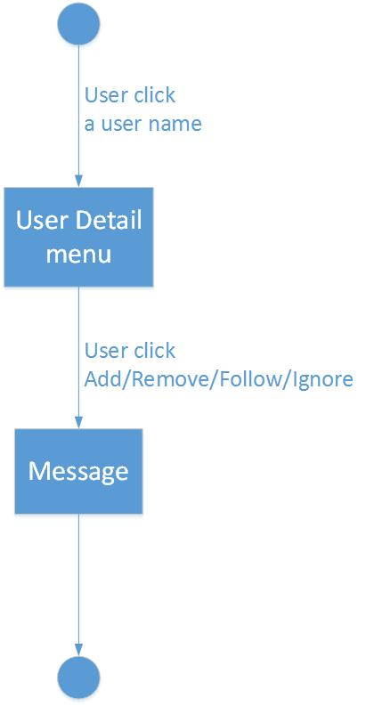

**Brief description**: User can use this function.

**Steps**:

Step 1: User click a user name in posts, comments or search results.

Step2: System return a menu.

Step 3: User click Add/Remove/Follow in menu.

Step 4: System return message.

### **Product Features**

FAP is a social network, user only connect to internet to use website. System provides these main functions:

**Search**: User and guest can search for places, food and drinks, experiences or friends and FAP will display results match with words user have searched. With searching features, user can easily search information of places they want to go, things they can experience at this places, and finding people who want to go to this place. The very new point and useful of FAP when compare with others is FAP is not only show the results match with words user have search but also show things related. User have the following searching option:

* + *Searching with name of places:* user can search with name of a place and FAP will display information about place(s), things related to this places (post, photos, reviews, suggestion etc…), friends and other users are going to/went to this place(s). FAP will also suggest rooms for user (information about room features are below)
  + *Searching with name of friends, group or another user:* user can search with name of friends, groups or another users (who is not friend with user), FAP will display basic information of user and link to user’s homepage
  + *Searching with name of food, drinks, or activities (skies, swimming, diving…):* user can search with name of food, drinks or activities…and FAP will suggest places to enjoying. FAP will also suggest like-minded people.
  + *Searching by maps:* User can search for a place directly on maps.

**Registering:** User can register an account and login to use all features of FAP

**Suggesting:** FAP can suggest places, activities or friends for user (must-go places, trendy activities, friend’s activities etc…)

**Look around:** User can check-in and look around their position and see suggestion about places, activities, experiences

**News feed:** User can see friend’s sharing

**Timeline:** User personal information and all posts will display on user’s timeline

**Sharing:** User can share their trips, destinations, photos, videos or write review to their personal page, their post will appear on the News Feed.

* **Like/dislike and comment:** User can like/dislike and comment on others’ post
* **Share:**  User can share a post (depend on this post’s privacy)
* **Report:** User can report a post to administrator

**Connecting:** Registered user can connect with others

* + **Add friends:** User can add other users as friends, friend’s posts will appear on user’s news feed.
  + **Follow other users:** User can see others’ post without become friends with those user
  + **Tagging:** User can tag friends to a post

**Room:** This is a new useful features of FAP for connecting users. In a room, user can discuss, share information and make a plan for their journey with others

* + **Create a room:** User can create a room with expected number of peoples
  + **Manage room:** User who has created the room as administrator can manage privacy of this room, manage resources and member of room. Admin of a room can set another to admin to share responsibilities.
  + **“Ready to go”:** When every member of room are ready to start a journey, the room will be temporarily closed
  + **Join to others’ rooms:** There are private room and public room, the privacy will be set by administrator of room
    - **Private room:** With this kind of privacy, room cannot be found in search result, user only can join a private room when they are invited by this room’s member.
    - **Public room:** With this kind of privacy, room can be found in search result, all of the users can join this kind of room.

**Managing account:** User can manage their personal information

* + **Login/Logout**: User can login to use more features of FAP. User can register an account to login or login by using Facebook, Google account.
  + **Changing password/Forgetting password**: User can change new password or require new password if user forgot current password.

**Managing member**: Admin can review report sent from users. If the report is reasonable, admin can delete post, send warning to user who has reported, admin can also lock/unlock users’ account.

### User characteristic

This website developed towards those who love travel, looking for a website to share about their trips, searching for information, review of places, searching for friends for new trips and keep in touch with their fellow traveler. The website requires users to have the ability to use a browser with an internet connection. If user want to use all function, they must be login.

There are three main actors that system support:

* **Guest:** Do not have account on system. In general, they can use common features (search a place, search food and drinks, search on maps) and register feature.
* **Member:** Have account on system, they can use all functions of website. For example: Searching, posting, connect to friends etc…
* **Administrator:** They can use all functions of normal member and have an Administrator control panel to manage all configuration of system.

## **Functional Requirements**

### **Common Module**

**Access right: Guest, Member**

Functions of this module can be used by Guest and Member.

Guest or Member can search for their needs, results may be places, foods, drinks or members’ name.

### **Suggest Module**

**Access right: Member**

Functions of this module can be used by Member only.

System suggest places, foods, drinks to members depend on their information, wish, places they have traveled. System also auto-detect member’s location or let member enter their location to suggest places that around member have traveled. If member sign in with Facebook, system can suggest their friends who are using services.

### **Social Module**

**Access right: Member**

Functions of this module can be used by Member only.

Member can create their own posts to share their experiences, suggestion, comments, upload their videos, pictures. Member also can delete or modify what they have posted. Moreover, member can like, dislike, comment, share other members’ posts and contents, tag friends. Member can add or remove other members from Friends List and Follow List. Member can report posts or comments because of spam or rule violation.

### **Room Module**

**Access right: Member**

Functions of this module can be used by Member only.

Member can create their own rooms to invite friends, other members to chat, discussion, make plans, starts up a trip. Member who created the room called as Room Admin, have all permissions of this room such as: invite, remove members, create, delete, modify room’s information, ban or unban from accessing, close and re-open room. When room’s members decide to do the trip, they can flag this room as done, and this room would be auto-closed.

### **Account Module**

**Access right: Guest, Member**

Functions of this module can be used by Guest and Member.

Guest can uses Register function to sign up new account, Member can login to use member’s functions. Member can modify their information such as: name, age, phone number and choose which information would be public.

### **Management Member’s account**

**Access right: Administrator**

This function is only used for Administrator User.

* Lock/Unlock Member’s Account: With this function, when a member violate some rules of website, Admin can block these member’s account temporarily, then these account cannot continue to use functions of website. Locked account will be unlocked when lock is expired. If these account violate rules one more time, Admin can lock account permanently.

Warn: If member violate the rules (reported by others), admin can send message to warn this people from stopping violation and delete/modify violated post.

### **Management Report**

**Access right: Administrator**

This function is only used for Administrator User.

* Delete Post: With this function, when a member post something on the wall but is reported by violate some rules of website, Admin can delete this post. Depending on severity, admin can lock or warn this user.

## **Non-functional Requirement**

* Easy to maintain and upgrade
* Ensure data security capabilities, high performance
* GUI is clear, friendly and easy to use.
* System has clear permission for user and can support multi roles.
* Scalability system